# Exploring Weather Trends – Project 1

## Outline:

* + Extract Data from Database using SQL Query:

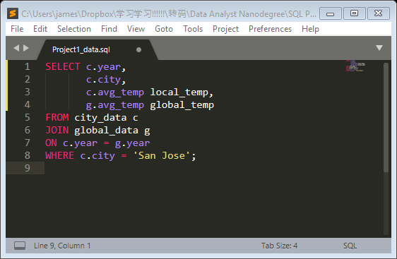

* + Open the CSV in Excel and calculate 5-year moving average:

## 

* + Plot 5-year moving average of both local and global temperatures in Excel:

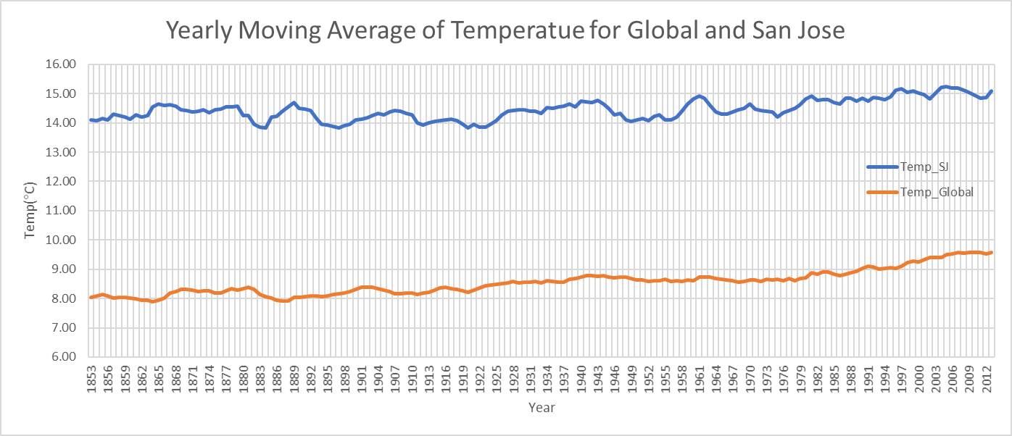

## Observations:

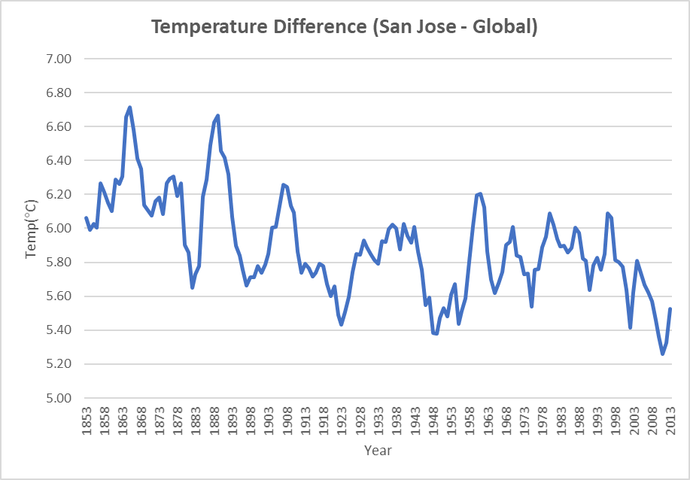

1. Overall average temperatures increase slowly over years for both global (14°C to 15°C) and San Jose (8°C to 9.5°C).
2. Current trend is not consistent to previous stable temperature trend over the 1750-1850.
3. San Jose’s local average temperatures increase more than global trend. And San Jose is hotter compared to the global average about 6 ± 0.7 °C.
4. The global/local temperature difference is narrowing graduall